**EXPERIMENT-2**

**By: Amogh Garg**

**AIM:** Implementation of Clipping and Clamping Circuits.

**SOFTWARE REQUIRED:** LTspice

**THEORY: DIODE CLIPPERS**: Depending on the features of the diode, the positive or negative region of the input signal is “clipped” off and accordingly the diode clippers may be positive or negative clippers. There are two general categories of clippers: series and parallel (or shunt). The series configuration is defined as one where diode is in series with the load, while the shunt clipper has the diode in a branch parallel to the load. Positive Diode Clipper In a positive clipper, the positive half cycles of the input voltage will be removed.

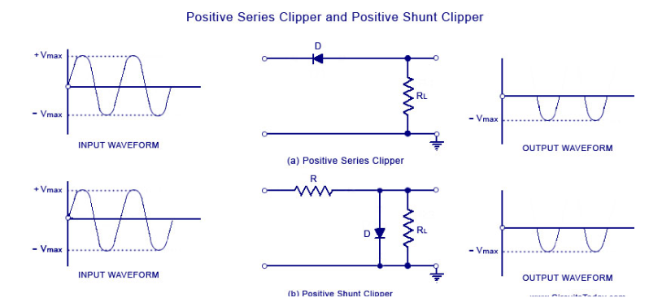

As shown in the figure, the diode is kept in series with the load. During the positive half cycle of the input waveform, the diode ‘D’ is reverse biased, which maintains the output voltage at 0 Volts. Thus causes the positive half cycle to be clipped off. During the negative half cycle of the input, the diode is forward biased and so the negative half cycle appears across the output.

**Negative Diode Clipper**

The negative clipping circuit is almost same as the positive clipping circuit, with only one difference. If the diode in figures (a) and (b) is reconnected with reversed polarity, the circuits will become for a negative series clipper and negative shunt clipper respectively. The negative series and negative shunt clippers are shown in figures (a) and (b) as given below.

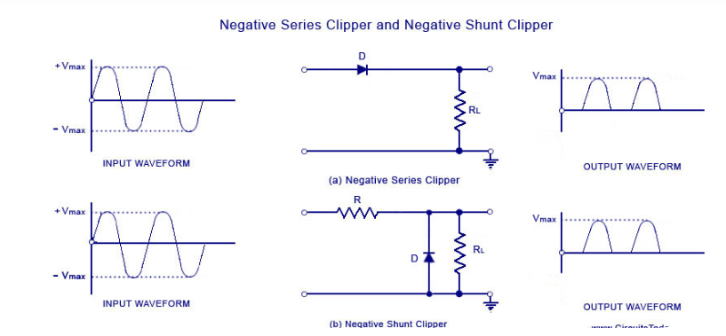

In all the above discussions, the diode is considered to be ideal one. In a practical diode, the breakdown voltage will exist (0.7 V for silicon and 0.3 V for Germanium). When this is taken into account, the output waveforms for positive and negative clippers will be of the shape shown in the figure below.

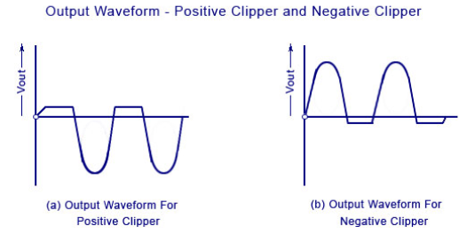

**DIODE CLAMPERS**: A clamping circuit is used to place either the positive or negative peak of a signal at a desired level. The dc component is simply added or subtracted to/from the input signal. The clamper is also referred to as an IC restorer and ac signal level shifter. A clamp circuit adds the positive or negative dc component to the input signal so as to push it either on the positive side, as illustrated in figure (a) or on the negative side, as illustrated in figure(b).The circuit will be called a positive clamper, when the signal is pushed upward by the circuit. When the signal moves upward, as shown in figure (a), the negative peak of the signal coincides with the zero level. The circuit will be called a negative clamper, when the signal is pushed downward by the circuit. When the signal is pushed on the negative side, as shown in figure (b), the positive peak of the input signal coincides with the zero level.

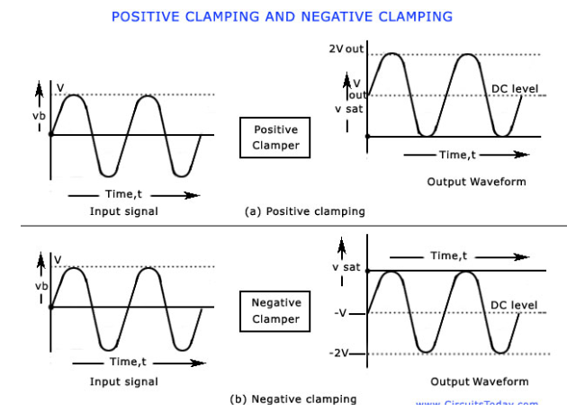

Consider a negative clamping circuit, a circuit that shifts the original signal in a vertical downward direction, as shown in the figure below. The diode D will be forward biased and the capacitor C is charged with the polarity shown, when an input signal is applied. During the positive half cycle of input, the output voltage will be equal to the barrier potential of the diode, V0 and the capacitor is charged to (V – VQ). During the negative half cycle, the diode becomes reverse-biased and acts as an open-circuit. Thus, there will be no effect on the capacitor voltage. The resistance R, being of very high value, cannot discharge C a lot during the negative portion of the input waveform. Thus during negative input, the output voltage will be the sum of the input voltage and the capacitor voltage and is equal to – V – (V — V0) or – (2 V – V0). The value of the peak-to-peak output will be the difference of the negative and positive peak voltage levels is equal to V0-[-(2V-V0)] or 2 V.

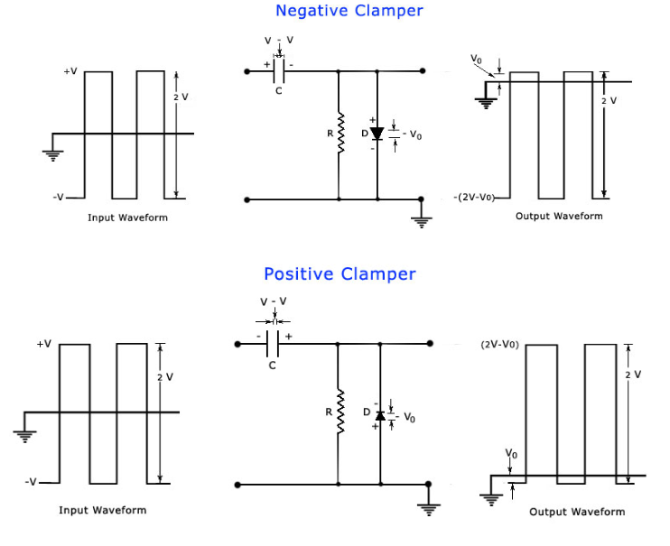

**OBSERVATION: CLIPPERS:**

Circuit(a): 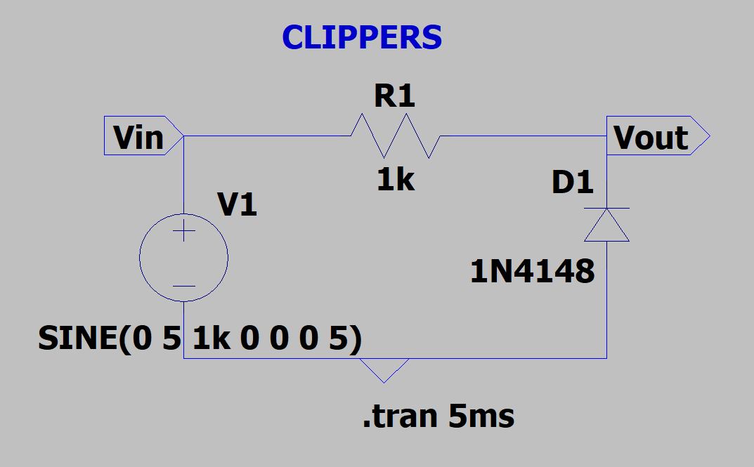

Output(a): 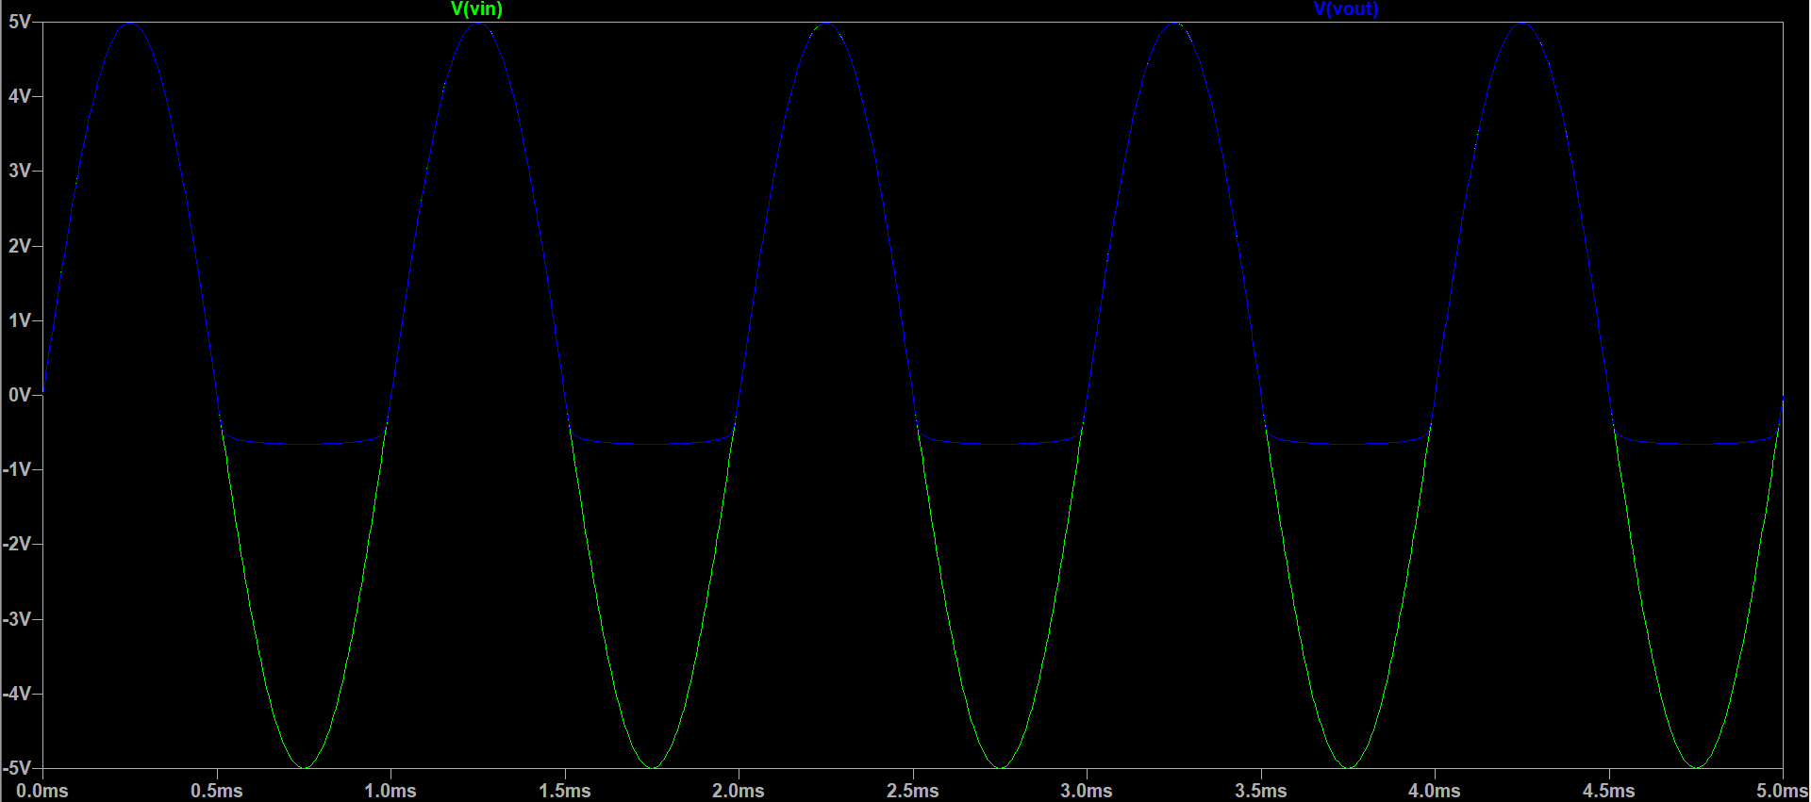

Circuit(b): 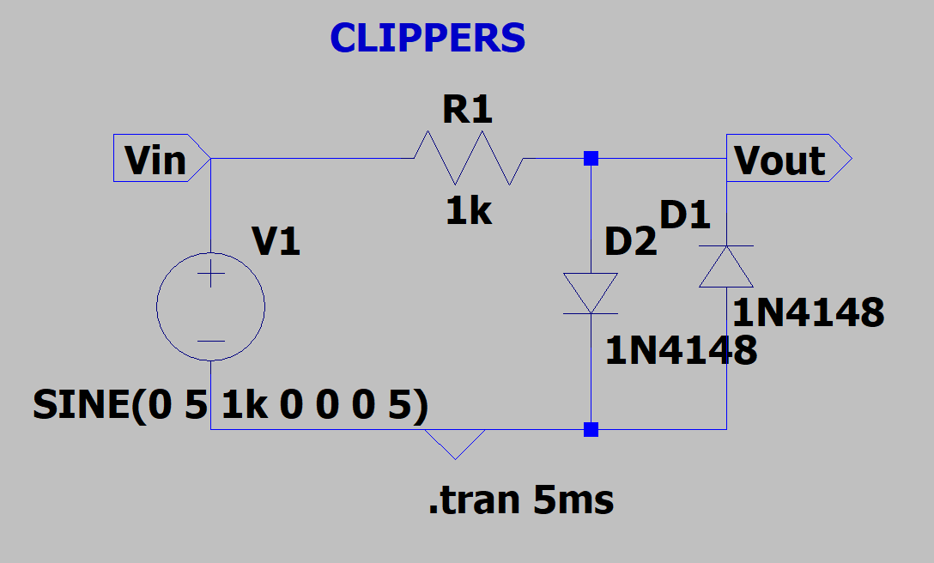

Output(b): 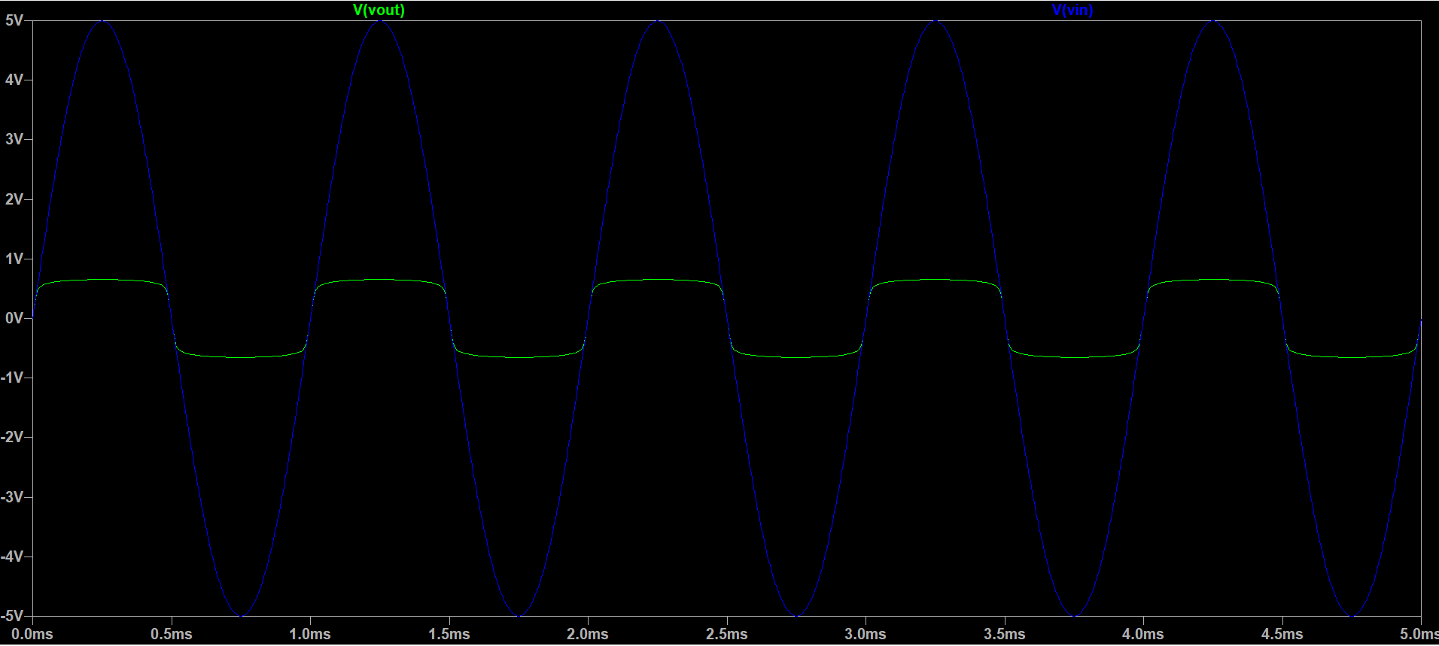

Circuit(c): 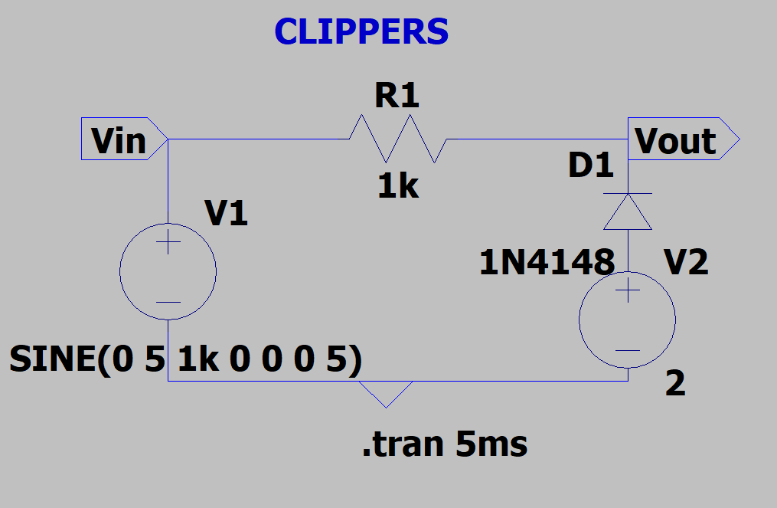

Output(c): 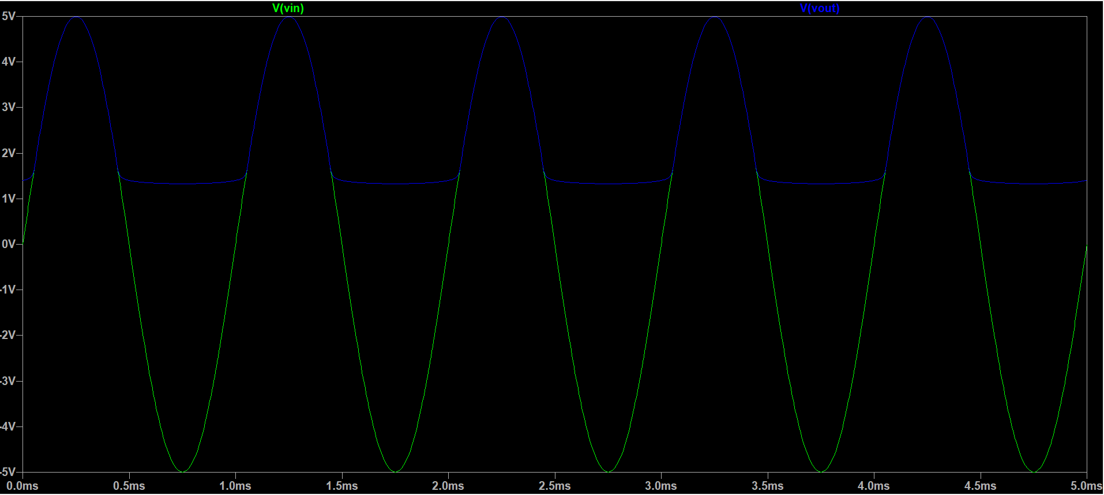

**CLAMPERS:**Circuit(a): 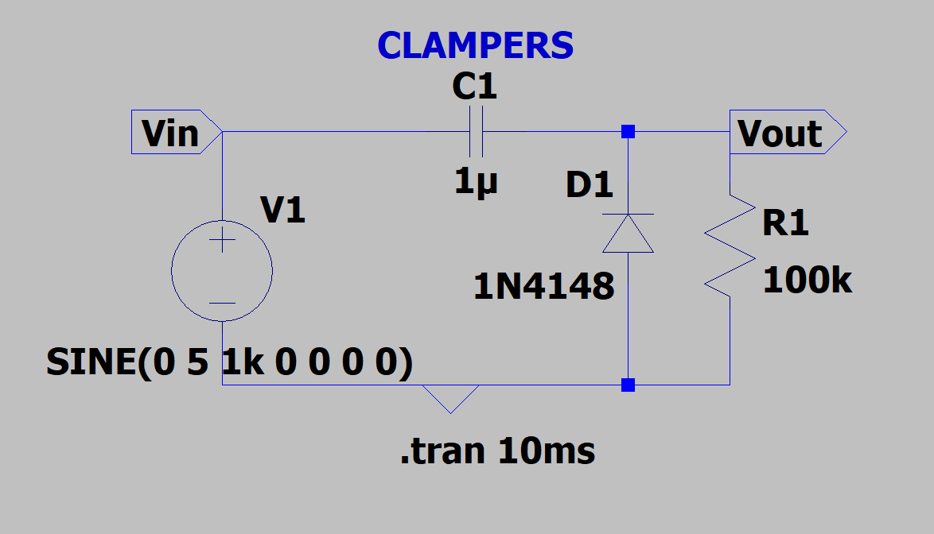

Output(a): 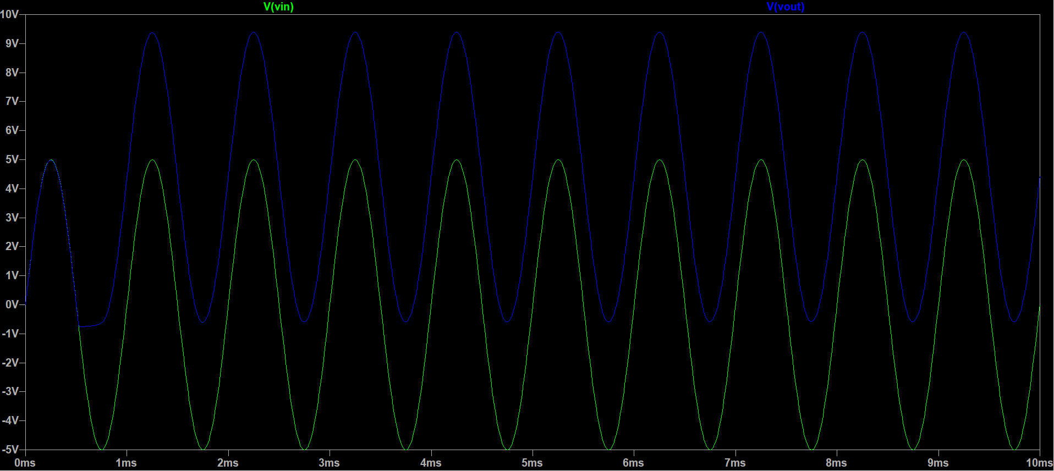

Circuit(b): 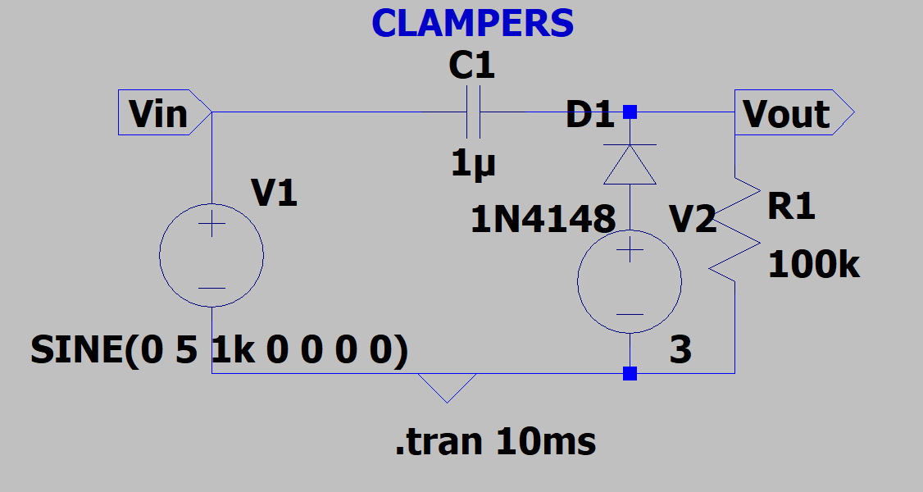

Output(b): 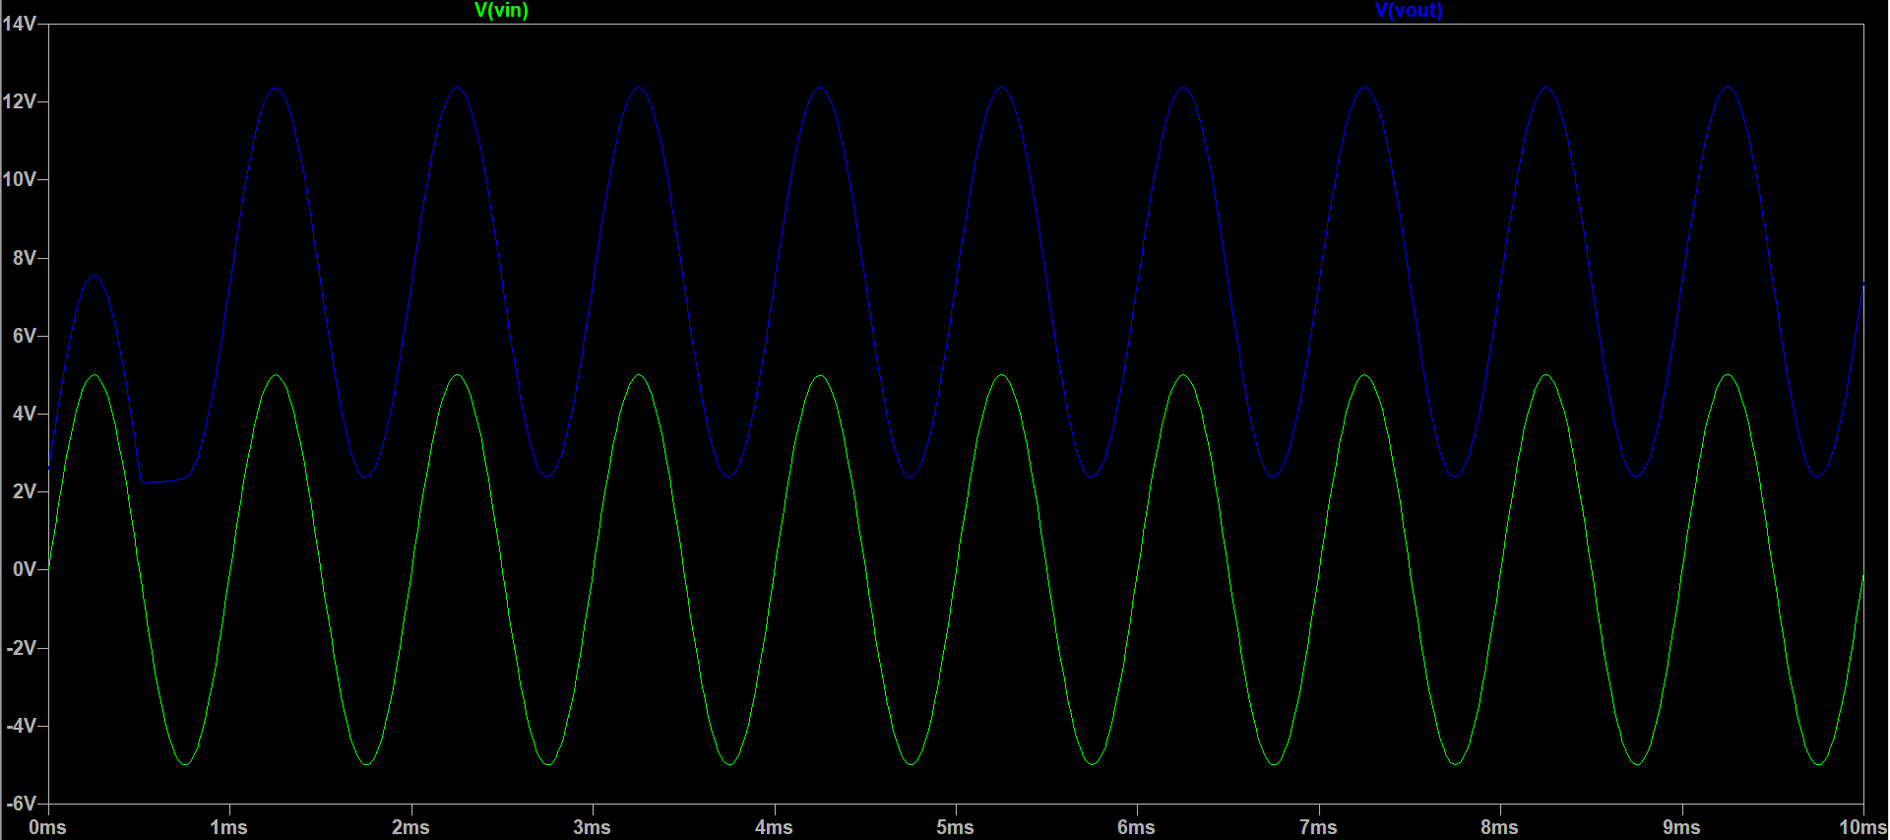

**RESULT:** The output wave-forms of diode clipping and clamping circuits are plotted.

**By:Amogh Garg**

**2020UCO1688**

**COE(Section-3)**